Instance with ORM Stack

Contents

1. Introduction 3
2. Workflow diagram to deploy the stack 3
3. Create Stack 4
4. Upload the Artifacts 5
5. Create VM 6
6. Plan the Job 9
7. Apply the Job 10
8. Verify in the Console 11
9. Destroy the stack 12

Introduction
In OCI (Oracle Cloud Infrastructure), an "instance" refers to a virtual machine (VM) or a compute resource running on the Oracle Cloud Infrastructure platform. Instances are used to deploy and run applications, service OCI (Oracle Cloud Infrastructure), an "instance" refers to a virtual machine (VM) or a compute resource running on the Oracle Cloud Infrastructure platform. Instances are used to deploy and run applications, services, and workloads within the Oracle Cloud environment.
This resource provides the Instance resource in OCI Core service. This creates a instance in the specified compartment and the specified availability domain.

When launch the instance, it is automatically attached to a virtual network interface card (VNIC). The VNIC has a private IP address from the subnet's CIDR.

Workflow diagram to deploy the stack
Below diagram shows how the Terraform Artifact are applied in the OCI. While creating a ORM stack, using terraform deliverables Init, Plan and Apply is the flow to provision the resource in the OCI. We can have the deliverables in any of below.
- GitLab/GitHub Repo
- Bitbucket
- Can be in folder/.zip in the local disk
- Object Storage Bucket
- Can be in compartment
- Oracle provided Template

Pre-request:

- Provied Image OCID
- Shape : VM.Standard.E4.Flex
- OCPU Count :1
- Memory (GB) : 16
- Subnet OCID
- Keep the SSH public key

Create Stack

Go to OCI Console Developer Services Resource Manager Stacks select the compartment Create Stack

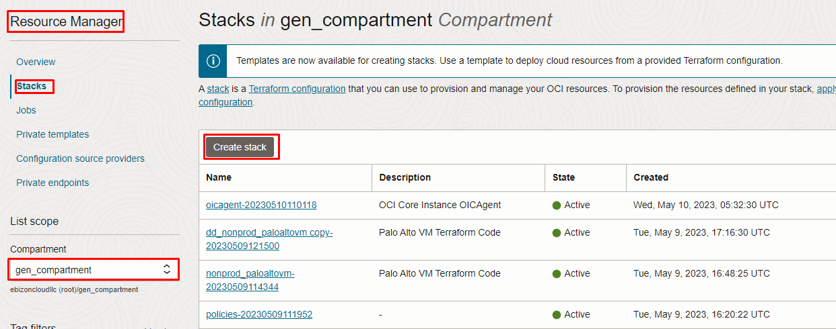

Upload the Artifacts

My Configuration Folder Browse

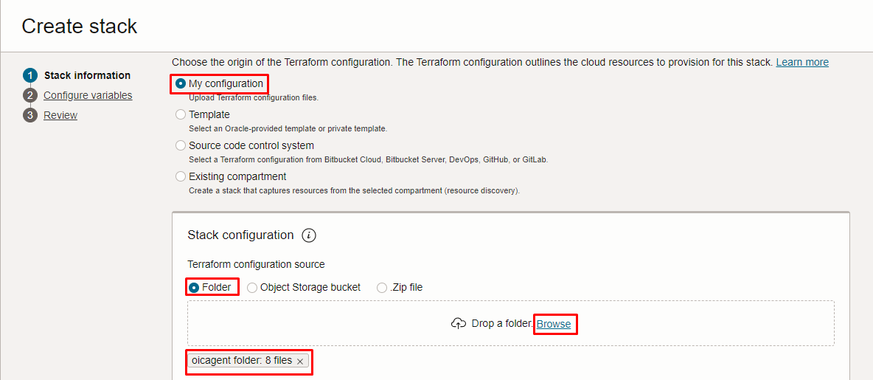

Select the “INSTANCE” folder that contains the terraform and yaml Upload

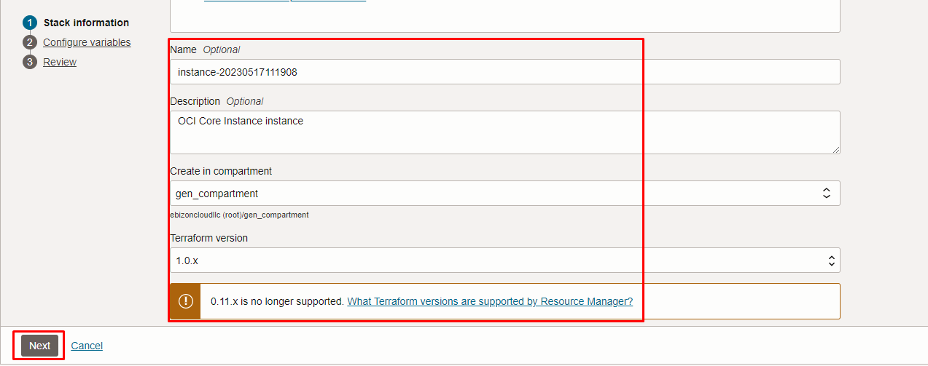

Click “NEXT”

Create VM

Select the parameters as per the below screen,

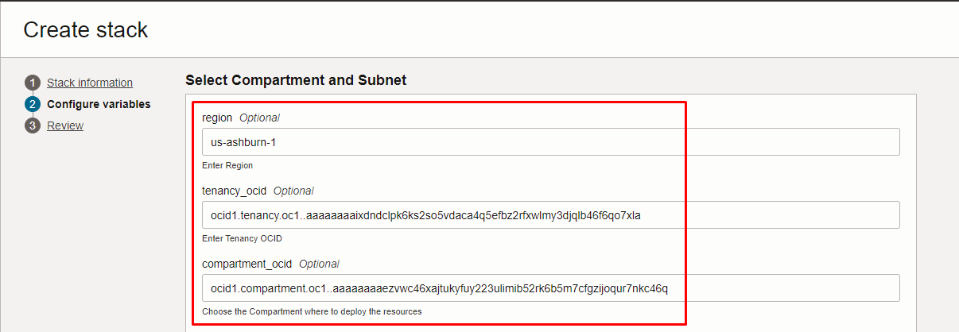
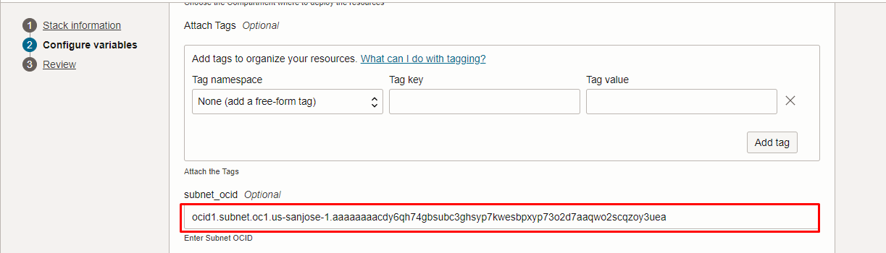
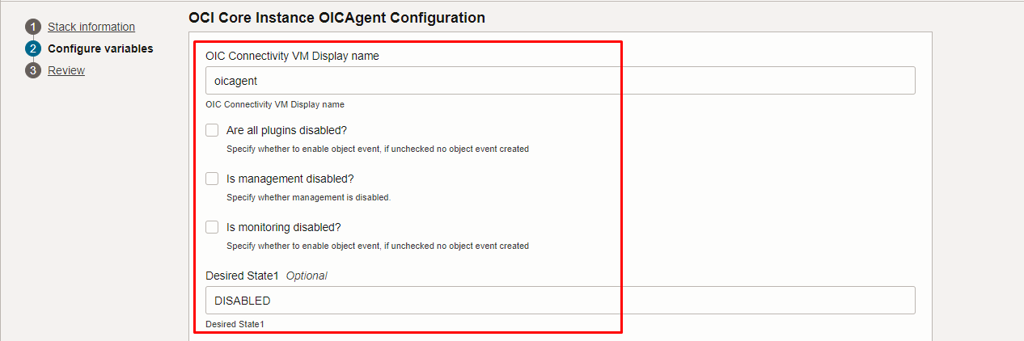
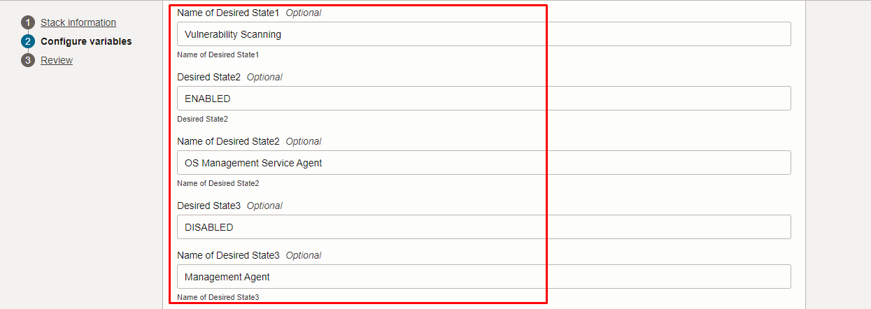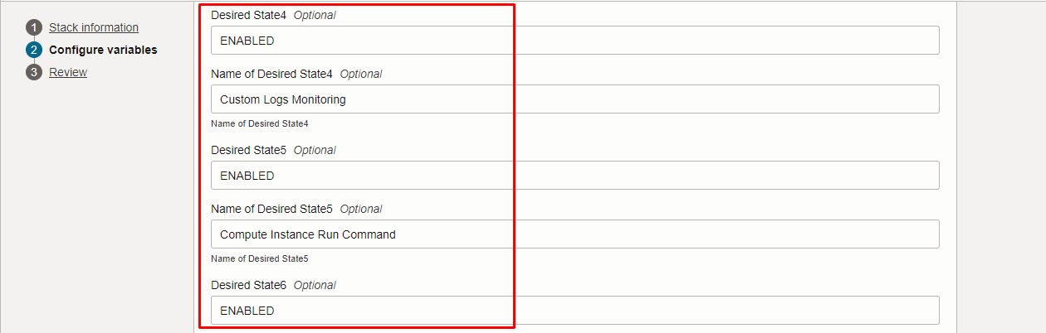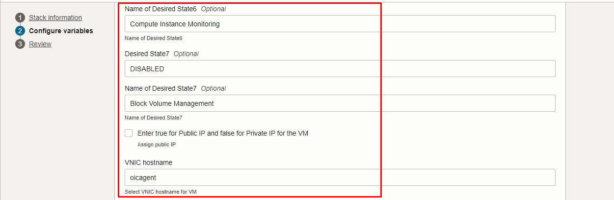
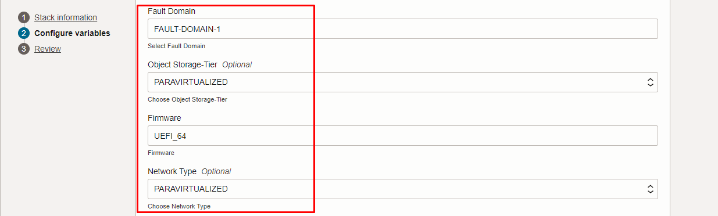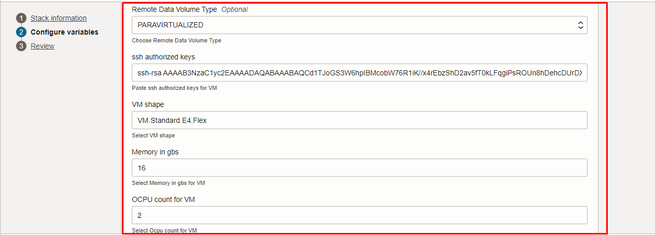
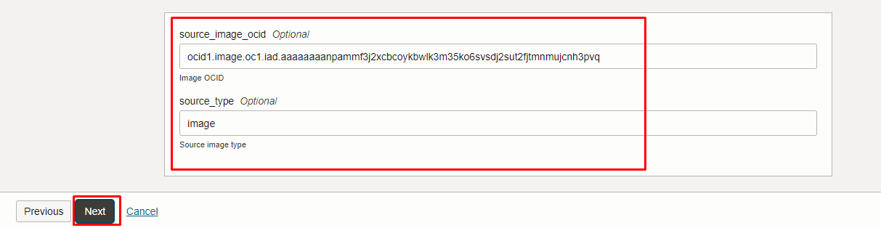

Click “NEXT”

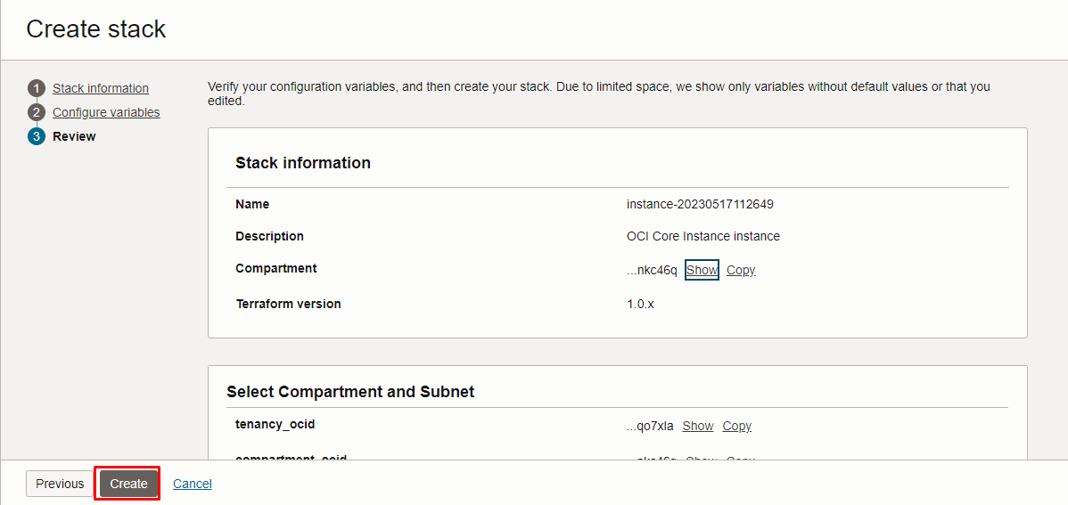

Click “CREATE”

Plan the Job

Click the “Plan”

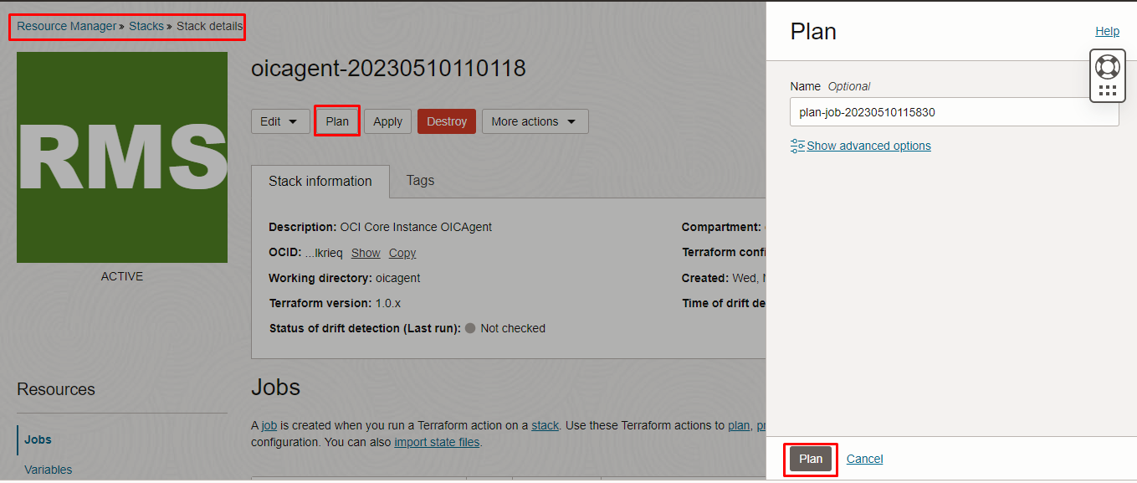

Verify the Plan is successful.
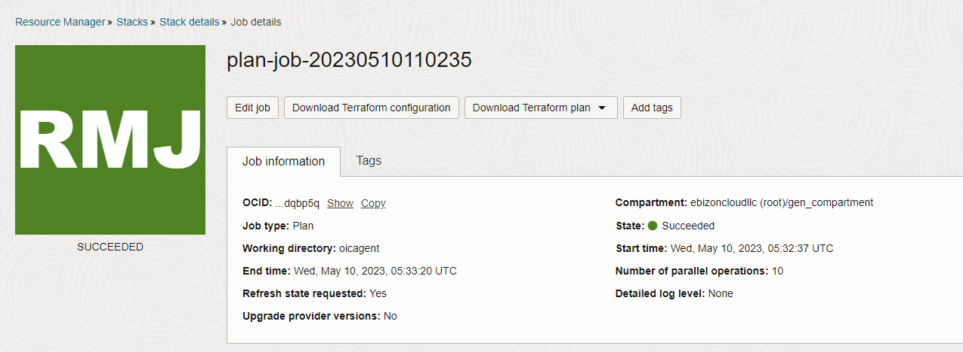

Apply the Job

Once the “plan” is success, now click “Apply”

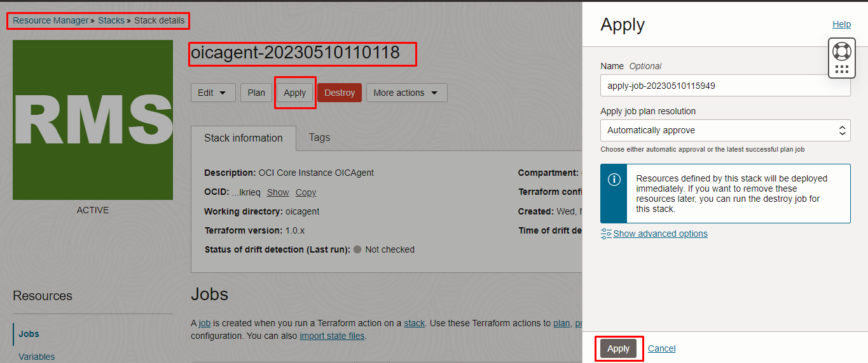

Verify the Apply is successful.

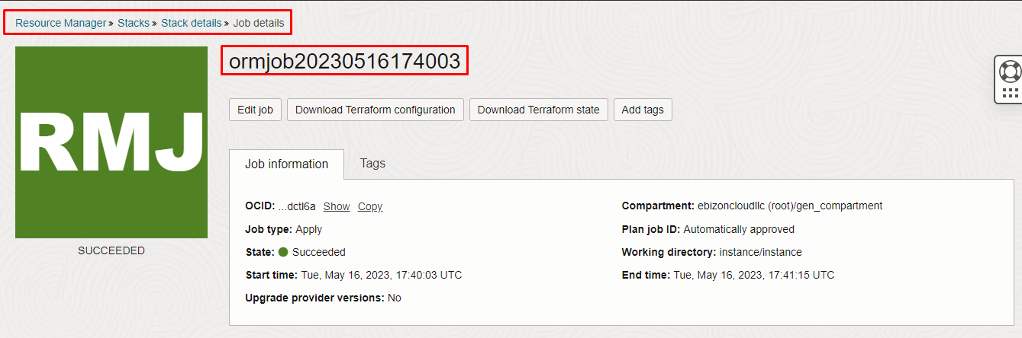
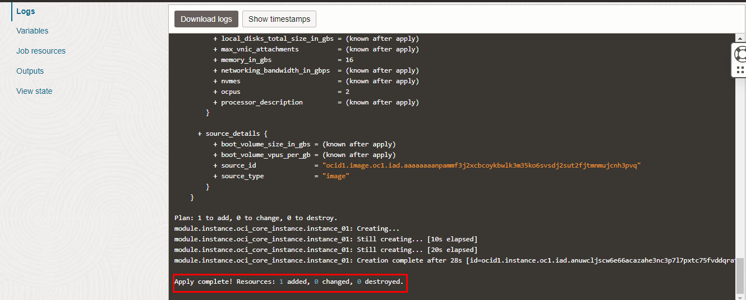

Verify in the Console

Go to OCI Console Compute Instance

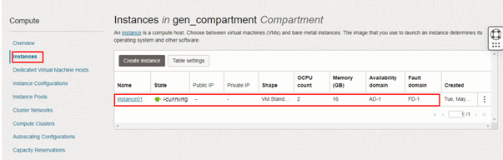

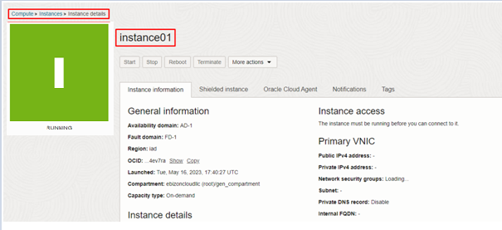
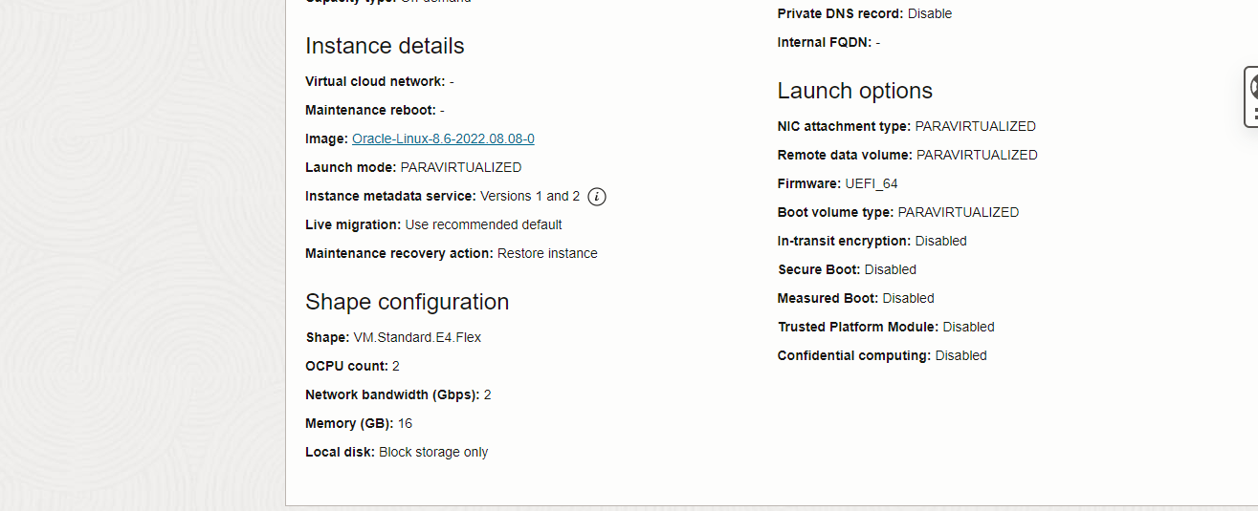

Destroy the stack
Create a destroy job in Resource Manager to release resources associated with a stack and clean up the tenancy. Once destroyed data cannot be recovered from resources

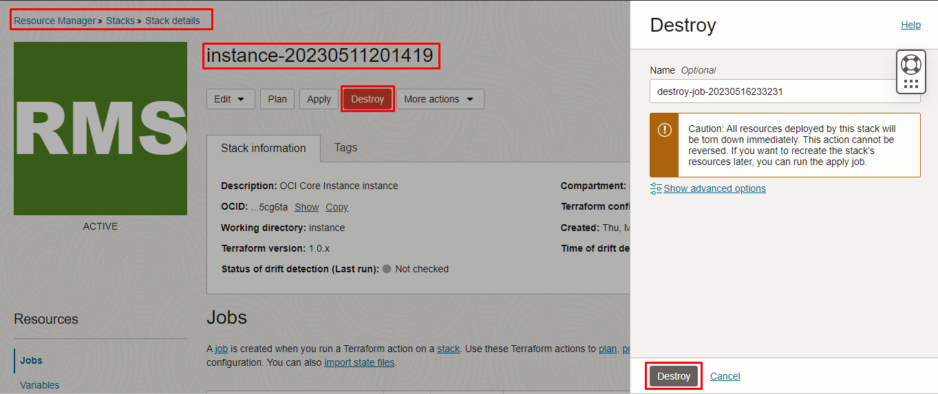

# END #

